

UNIVERSITI TEKNIKAL MALAYSIA MELAKA
FAKULTI TEKNOLOGI MAKLUMAT DAN KOMUNIKASI

W O R K S H O P 1

R E P O R T

Name | : Yaseen Mohamed Awad Sharif
Matric Number | : B032220060
Program | : BITI
Project Title | : Hotel Management System
Supervisor Name | : DR. NORHAZWANI BINTI MD YUNOS
Supervisor Signature Evaluator Name | :  : DR. YOGAN A/L JAYA KUMAR

EXECUTIVE SUMMARY

Title: Hotel Management System

A command-line program called the Hotel Management System was created to improve visitor experiences and expedite hotel operations. It unifies staff management, billing, reservation management, room tracking, and guest services onto a single platform. Simple booking procedures, effective capacity monitoring, expedited receipt of payments, task delegation, and customized visitor experiences are among the notable advantages. Robust reporting is also provided by the system. Benefits include cost savings, capacity, and greater efficiency. The system offers hoteliers an easy-to-use interface for efficient operation management.

TABLE OF CONTENTS

PAGE
EXECUTIVE SUMMARY i
TABLE OF CONTENTS ii
Chapter 1: INTRODUCTION 1
1.1 Introduction 1
1.2 Problem Statement 1
1.3 Objective (s) of the project 1
1.4 Scope 2
1.4.1 Module to be developed 2
1.4.2 Target User 2
1.5 Project Significance 2
1.6 Gantt Chart of Project Activities 2
Chapter 2: ANALYSIS OF PROBLEM 4
2.1 Problem Decomposition Description 4
2.2 Structured Chart 4
5
Chapter 3: DESIGN 6
3.1 Flowchart 6
3.2 ERD 16
3.3 Data Dictionary 17
3.4 Interface Design 19
Chapter 4: IMPLEMENTATION 29
4.1 Naming Convention 29
4.2 Function 31
4.3 Array 33
4.4 Selection 34
4.5 Control 36
4.6 Pointer 38
4.7 Error Handling 39
Chapter 5: CONCLUSION 45
5.1 Constraints 45
5.2 Future Improvements 46
REFERENCES 48

INTRODUCTION

Introduction
Efficient hotel operations are vital for great guest experiences and revenue optimization in the hospitality industry. Manual methods for handling bookings, check-ins, check-outs, and billing are prone to errors and inefficiencies. Developing a robust Hotel Management System (HMS) is crucial to streamline operations, automate key procedures, and empower hotel employees to deliver superior guest experiences.

Problem Statement
The manual administration of hotel operations poses several difficulties. First of all, it is vulnerable to mistakes, which can result in problems like duplicate reservations, imprecise inventory control, and delays in providing guest service, also one assigning a room should be automatically when the room is booked. Second, without automation, it gets difficult and time-consuming to manage different duties including room assignments, guest check-ins and check-outs, housekeeping schedules, and billing.

Objective (s) of the project
This project embarks on the following objectives:
To develop and design a comprehensive Hotel Management System (HMS) using C++, that automates key hotel operations such as reservations, check-ins, check-outs, and billing.
To assess the effectiveness of the HMS in streamlining hotel operations, reducing errors, and enhancing guest experiences.
To make recommendations based on the evaluation of the HMS, suggesting improvements or additional features to further optimize hotel management processes and maximize guest satisfaction.

Scope

Module to be developed
Reservation Management Module: This module allows hotel staff to manage room reservations, including checking availability, making new reservations, modifying existing reservations, and canceling reservations.

Target User
Hotel Admin, Staff and Customers, But The primary users of the Hotel Management System (HMS) are hotel employees, including front desk staff, reservation manager, And billing personnel. These users will utilize the system to efficiently manage hotel operations and provide excellent service to guests.

Project Significance
Improved Guest Experience: Streamlined processes lead to smoother check-ins and better guest satisfaction.

Operational Efficiency: Computerized system reduces errors, optimizes resource use, and boosts staff productivity.

Scalability and Adaptability: The system can easily adapt to industry changes, ensuring long-term sustainability and growth.

Gantt Chart of Project Activities
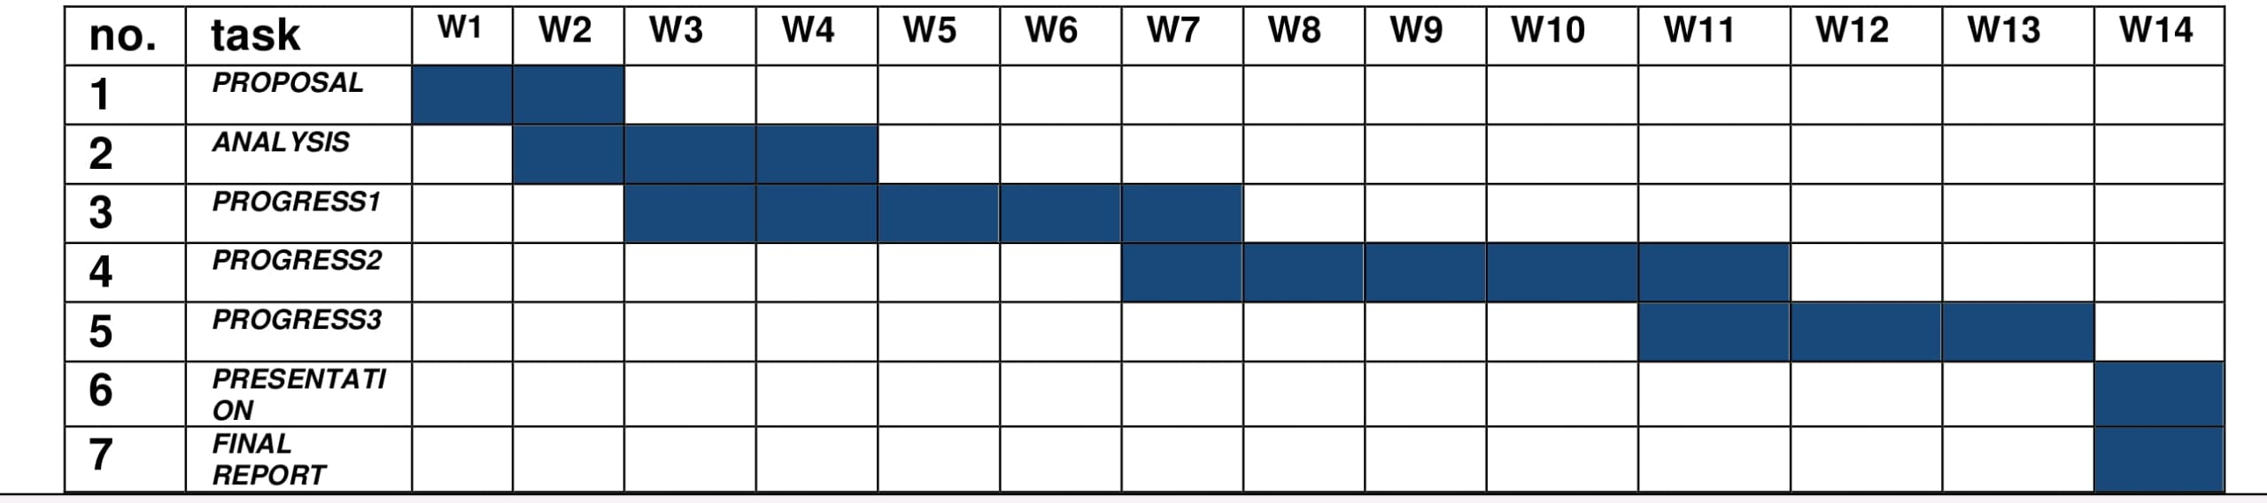

ANALYSIS OF PROBLEM

Problem Decomposition Description
Reservation Management: Break down tasks into checking availability, creating, modifying, and canceling reservations.

Check-in and Check-out Process: Decompose into guest registration, room assignment, key issuance, payment processing, and room status updates.

Inventory Management: Decompose tasks into tracking availability, managing room types, allocations, and amenities.

Billing and Invoicing: Break down into calculating charges, generating invoices, processing payments, and maintaining records.

Structured Chart

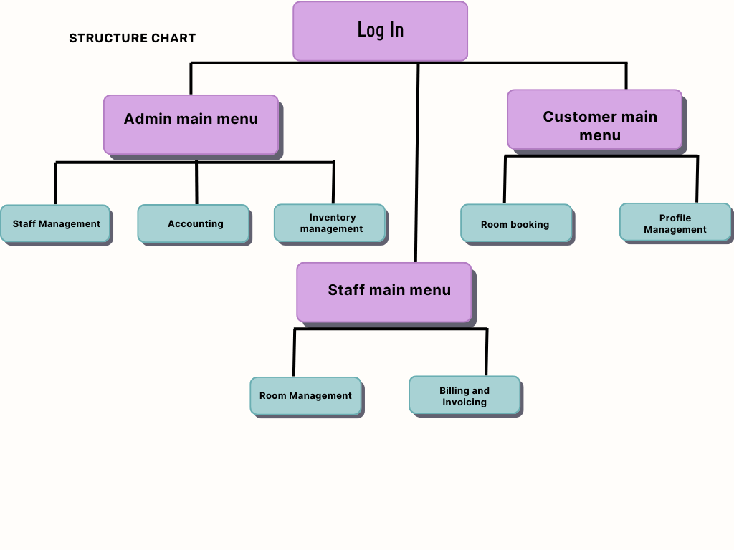

DESIGN

Flowchart
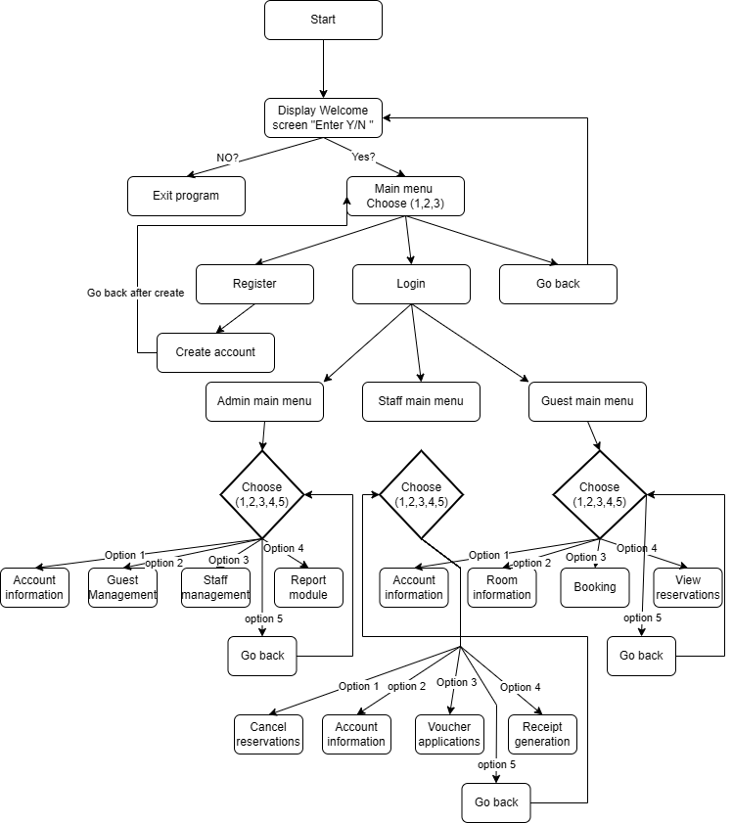
Figure 1.1 - System Overview

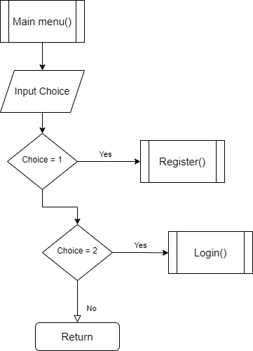
Figure 1.2 - Main menu function

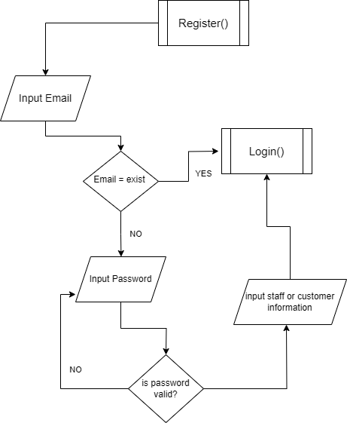
Figure 1.3 - Register function

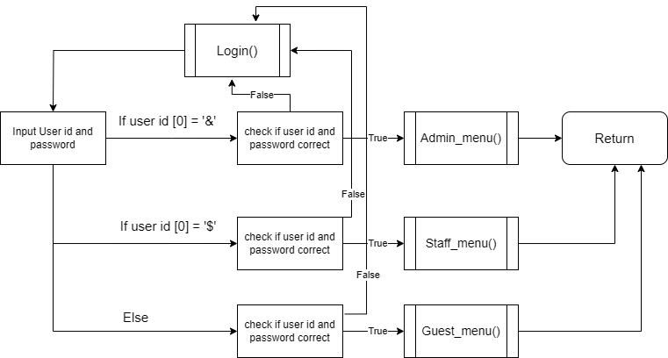
Figure 1.4 - Login function
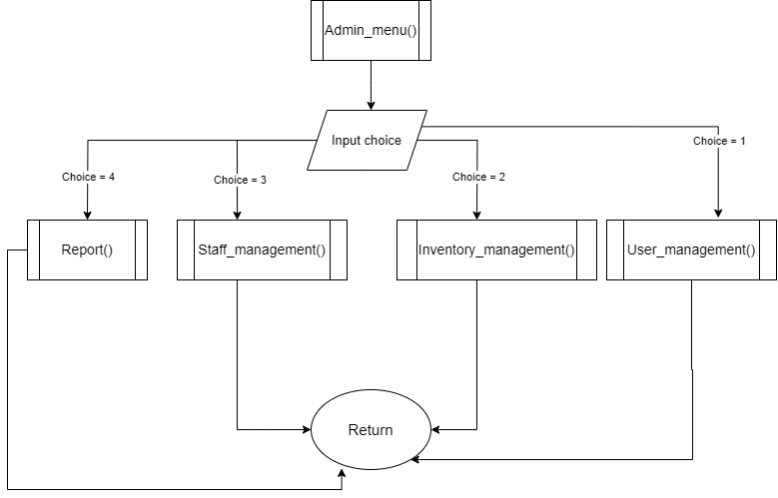
Figure 1.5 – Admin main menu function
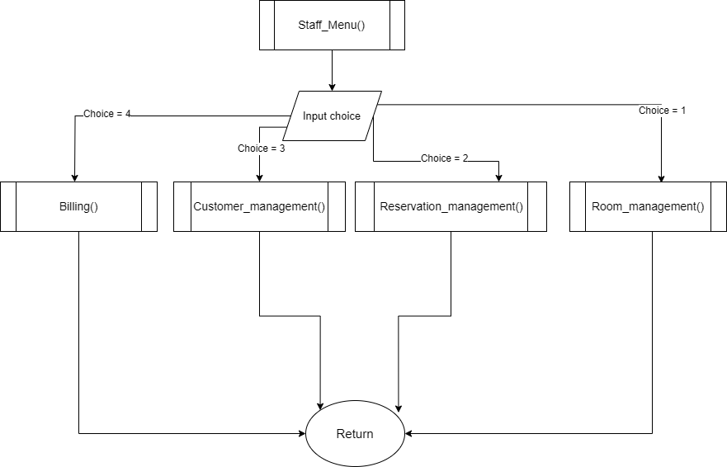 Figure 1.6 – staff main menu function
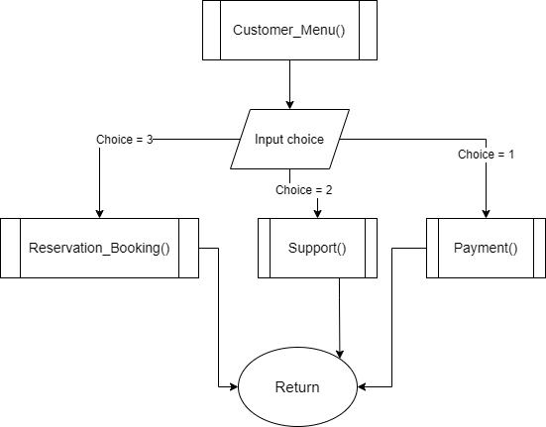
Figure 1.7 – Guest main menu function
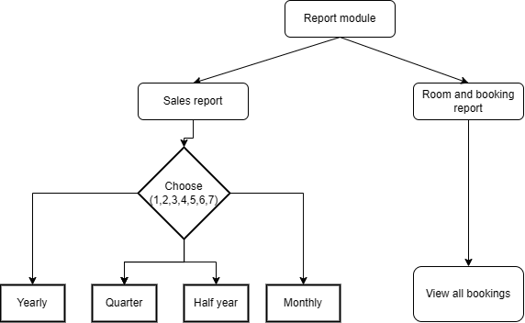
Figure 1.8 – Report module function
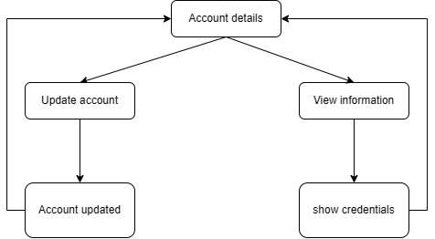
Figure 1.9 – account information function
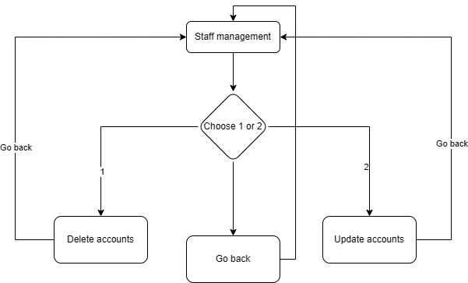
Figure 2.0 – Staff management function
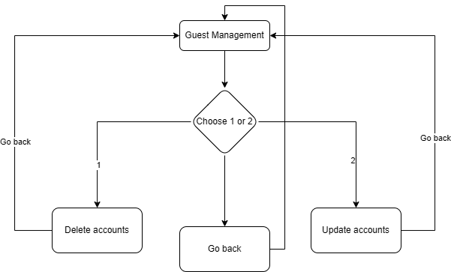
Figure 2.1 – Guest management function
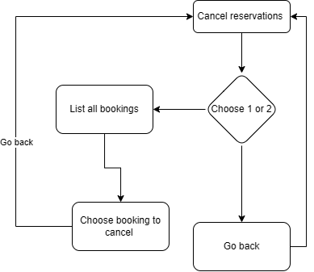
Figure 2.2 – cancel reservation function
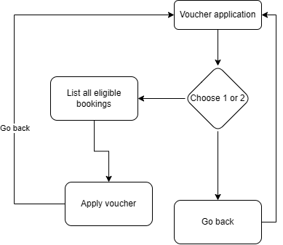
Figure 2.3 – Voucher application function
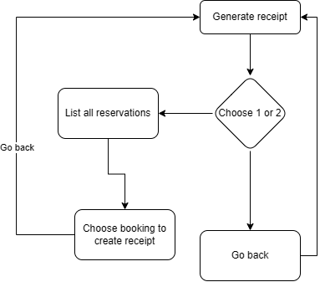
Figure 2.4 – receipt generation function
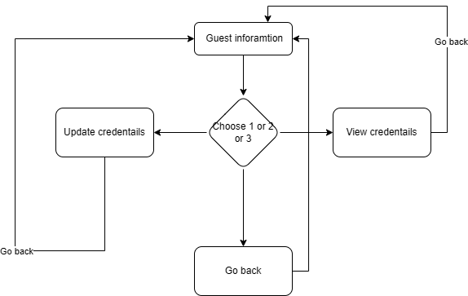
Figure 2.5 – Guest account information function
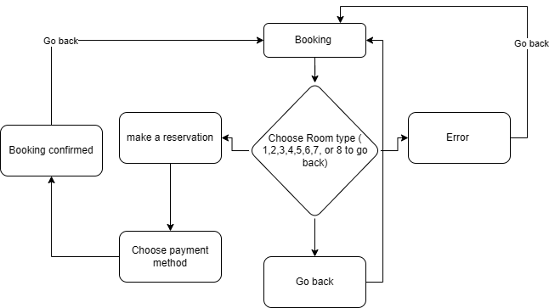
Figure 2.6 – Booking function

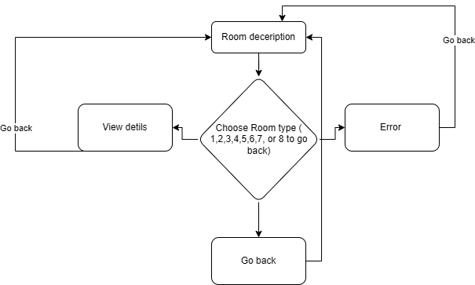
Figure 2.7 – Room deception function

ERD
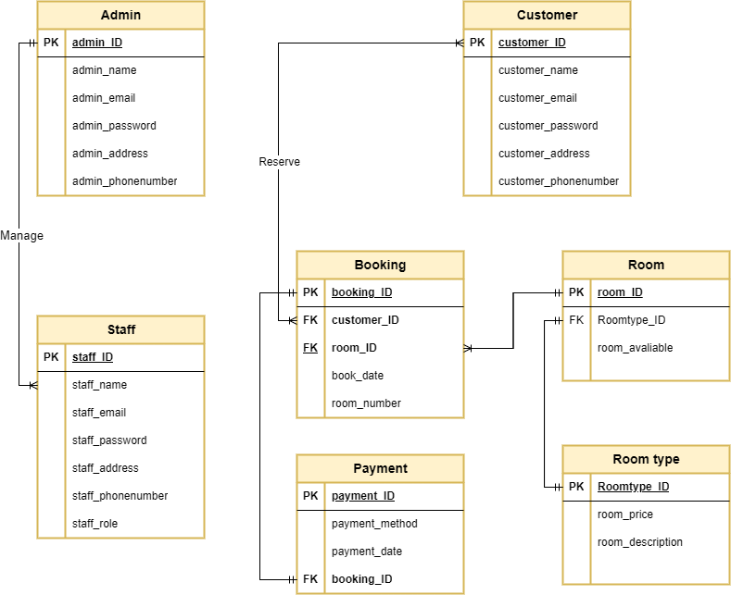

Business rules:
-customer can have one or many booking
-room can be booked one or many times
-booking can be made by one or many customers
-Admin can manage one or many staff members
-A room must have a specific room number
-A payment must be made for a booking
-staff can be managed by one and only one admin
-Room can have one and only one room type

Data Dictionary
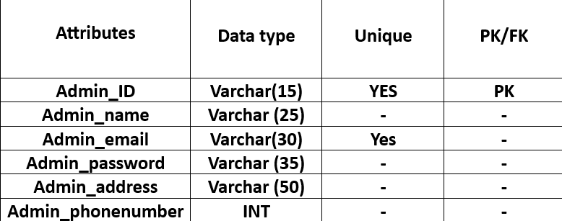
ADMIN TABLE
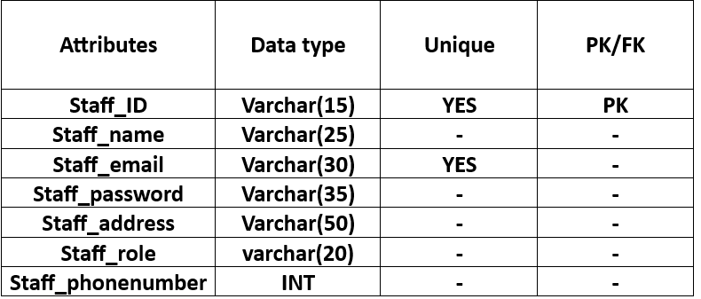
STAFF TABLE
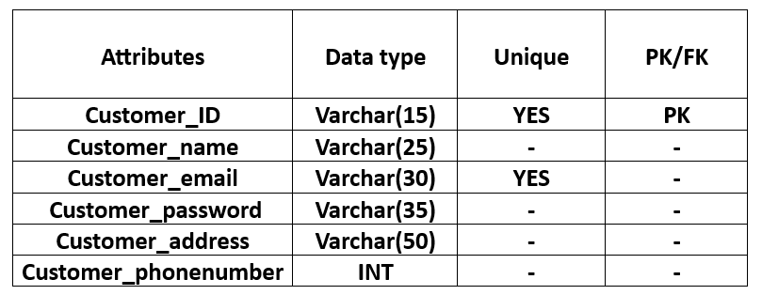
CUSTOMER TABLE
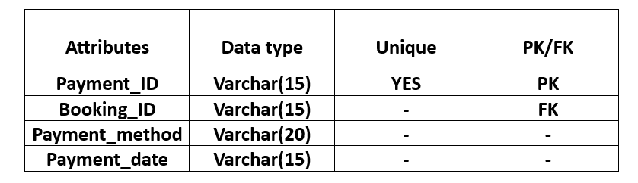
PAYMENT TABLE
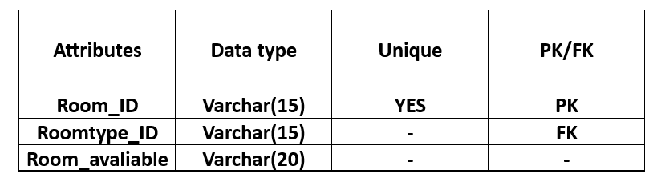
ROOM TABLE
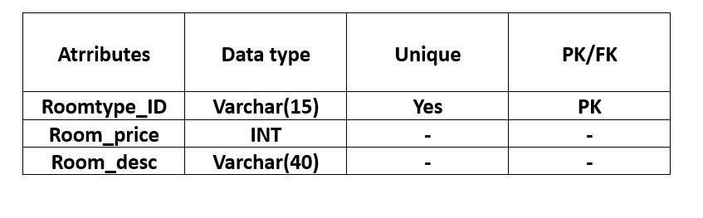
ROOM TYPE TABLE

Interface Design
- This is the Welcoming menu where you can choose either entering the system or not.
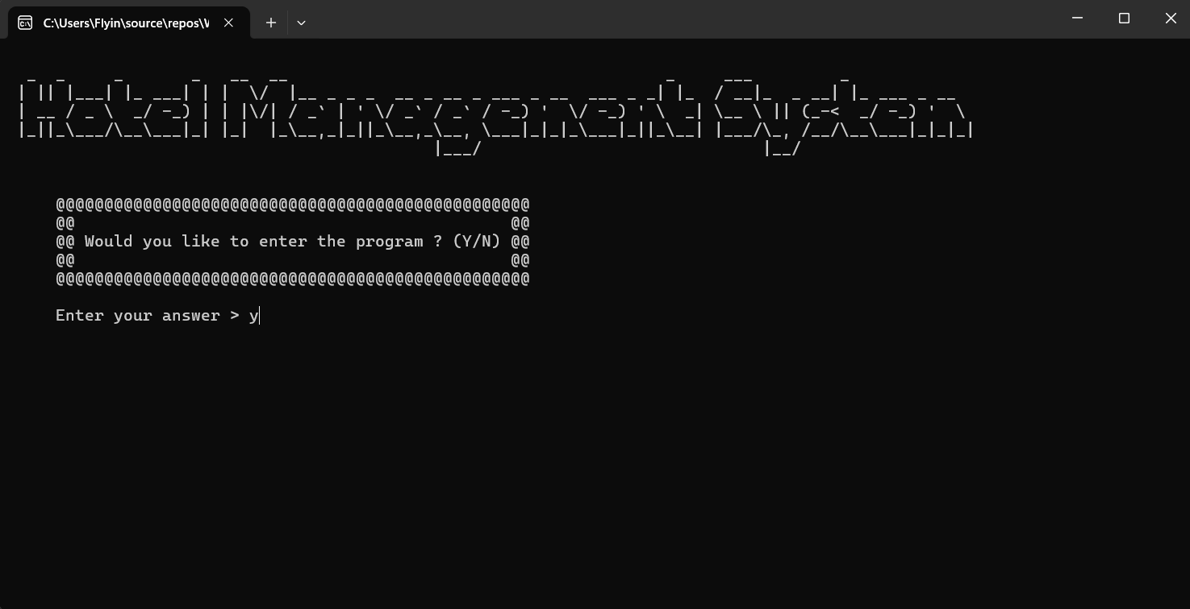
- This is the Main menu of the system where you can choose whether you want to register, Login or go back to the previous menu.

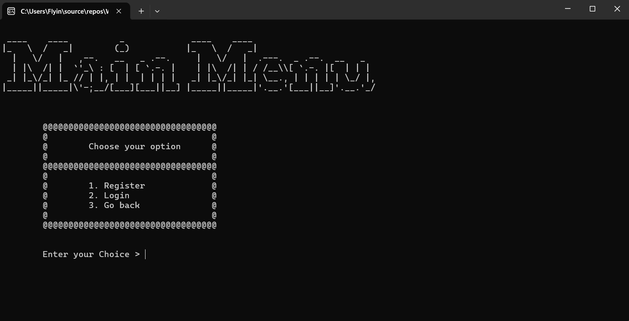
- This is the Register design you will be asked to enter all credentials or go back .
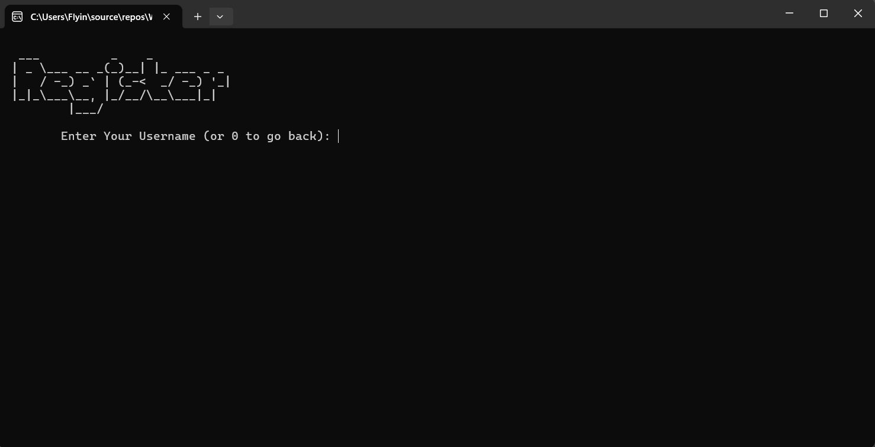

- This is the login design where you need to enter the registered credentials.
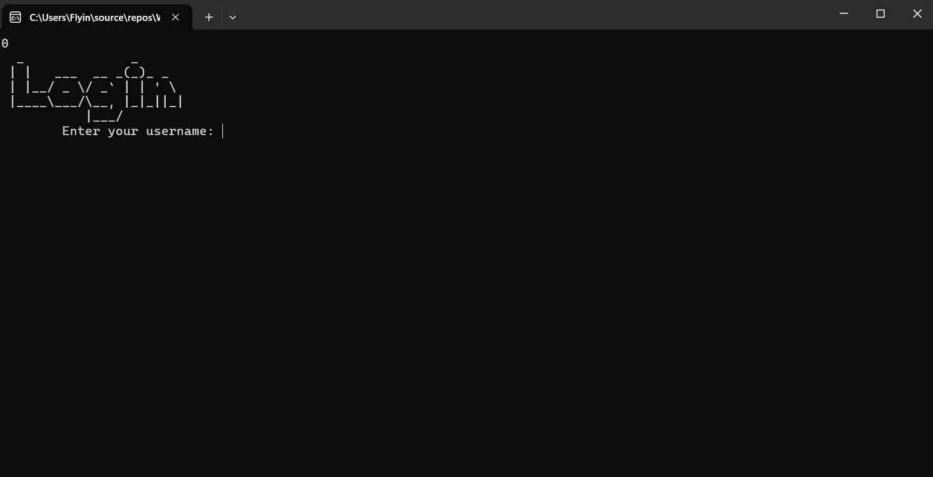
- This is the Admin main menu design Where you can choose up to four services .
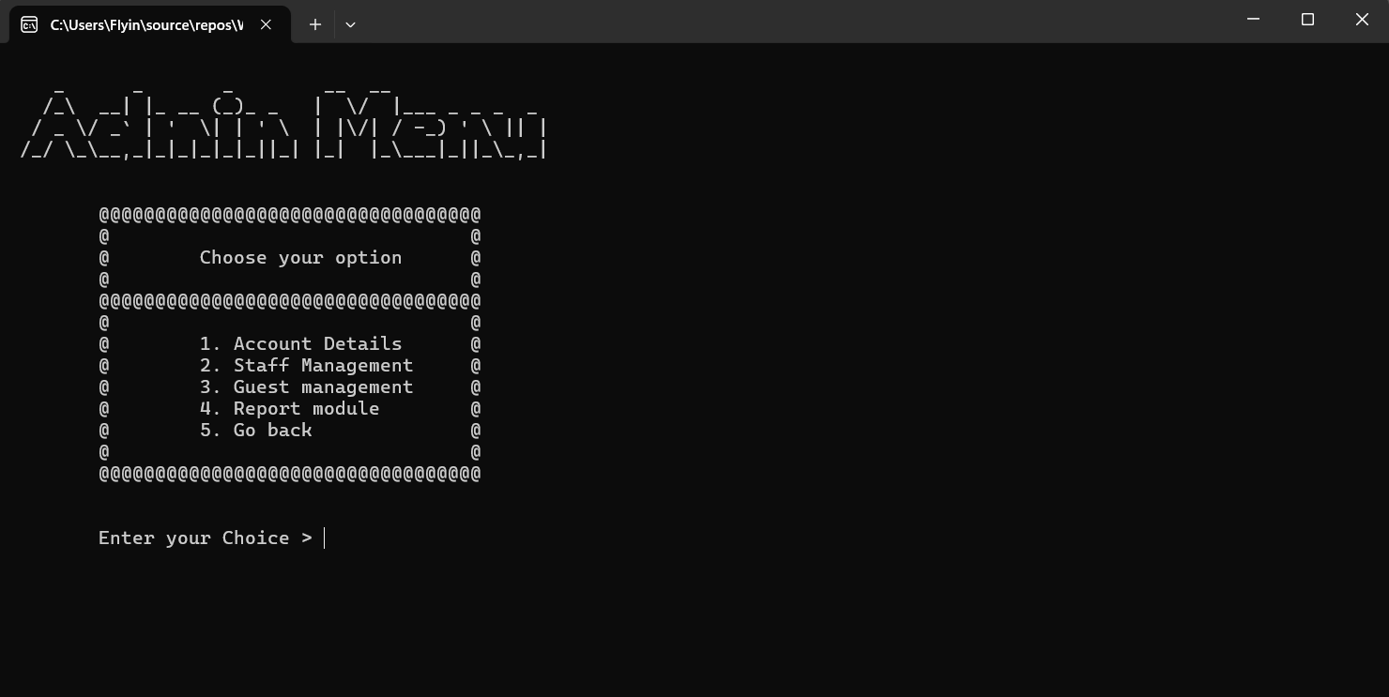

- First Admin service is Account details where you can update or view credentials.
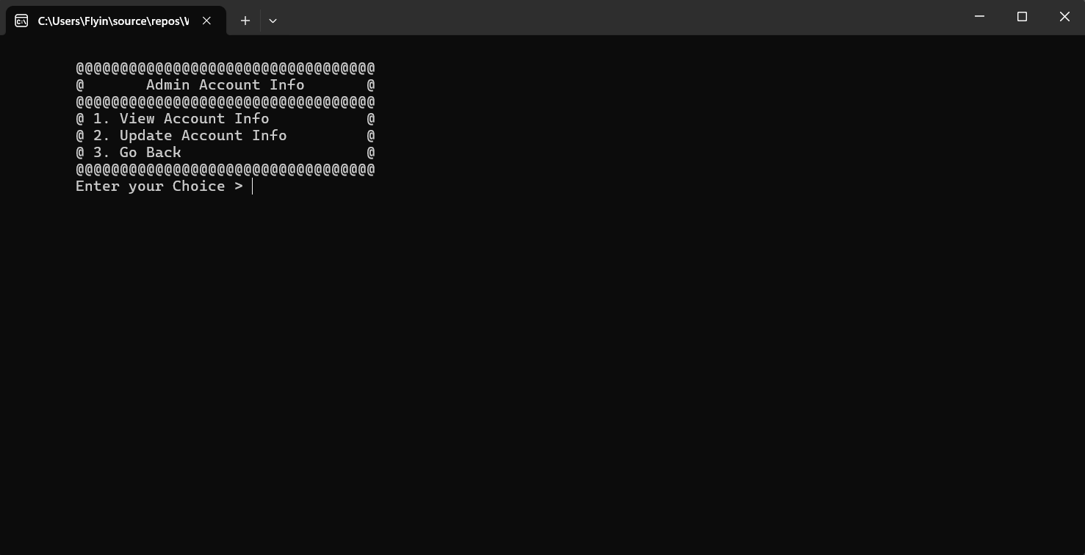
- Second Admin service is Guest management where you can add, update and delete users.
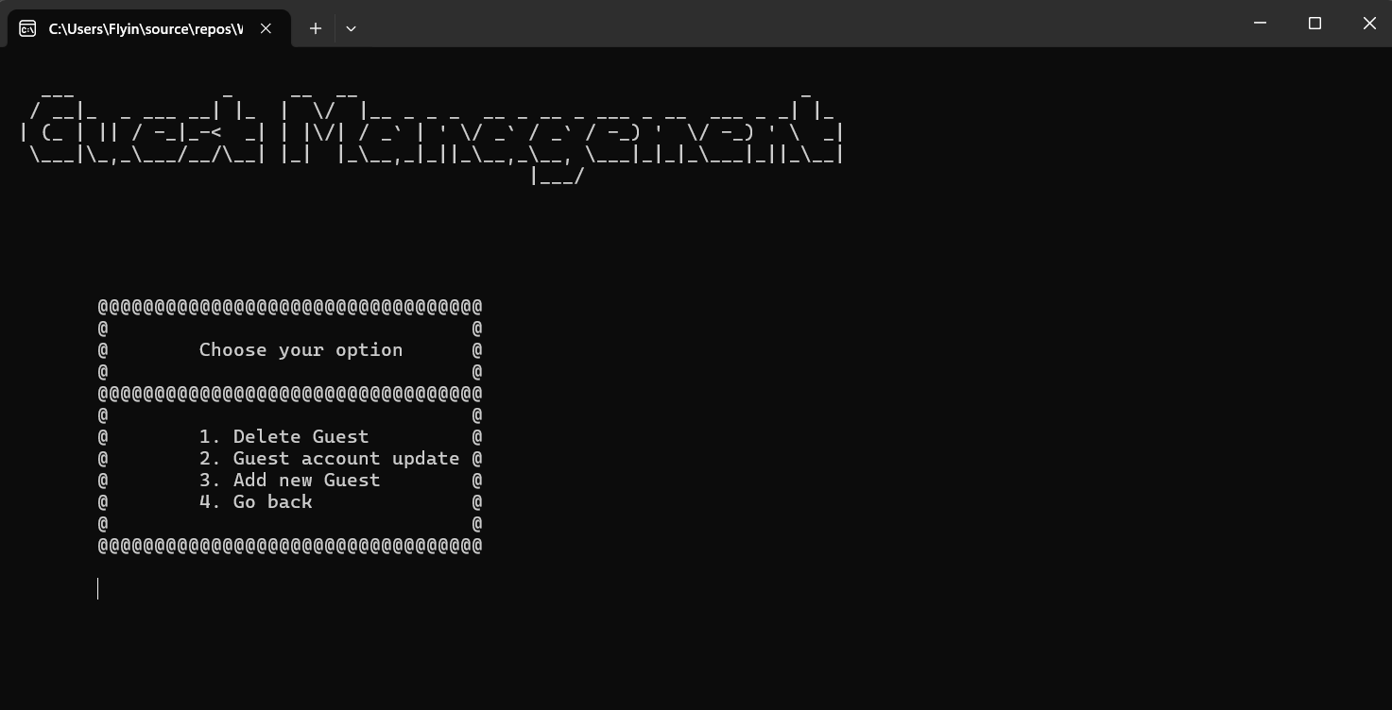

- Third Admin service is Staff management where you can choose to Expel, Hire or Update staff info.

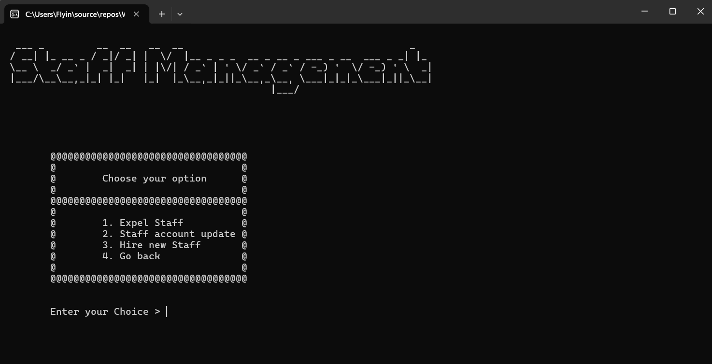
- Fourth Service is Report which has two major Functions:
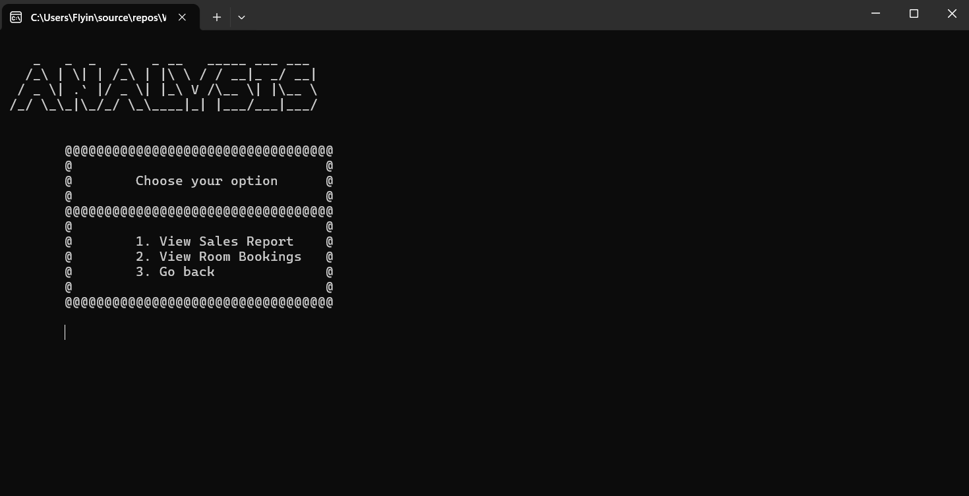
- Next is Staff main menu interface where you can choose for up to 4 services.

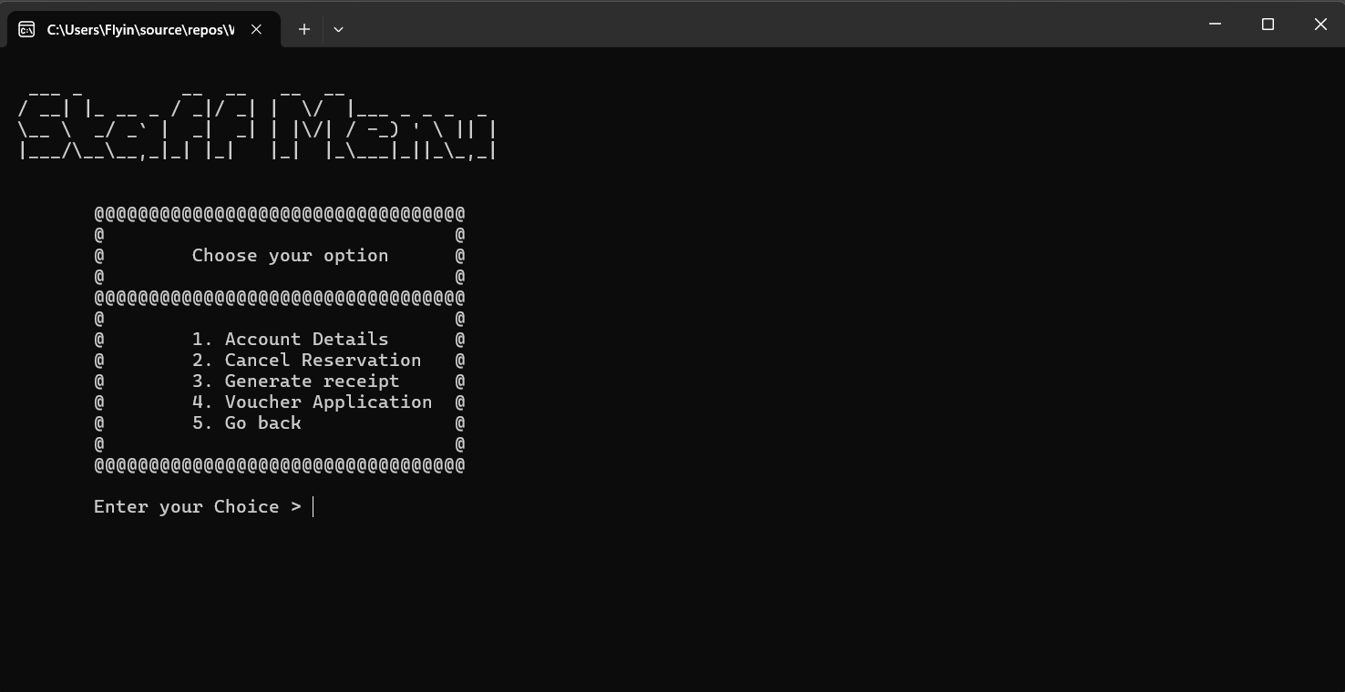
- First service is Account details where you can view all.
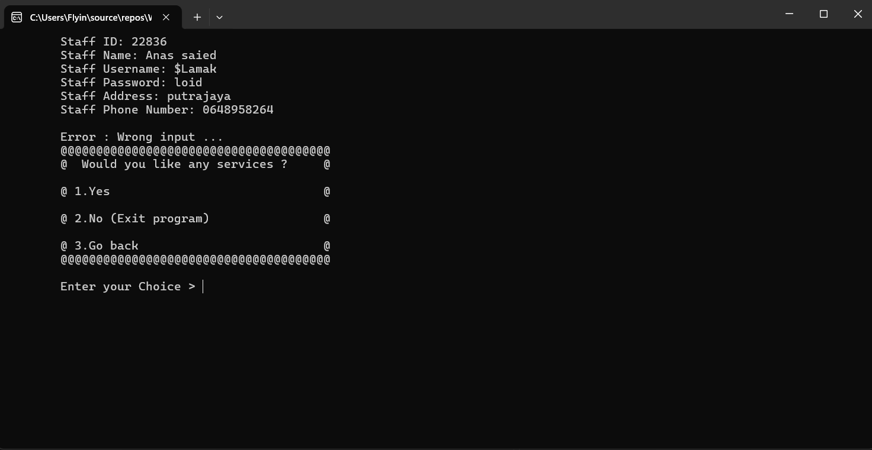

- Second Service is Cancel reservations for any booking.
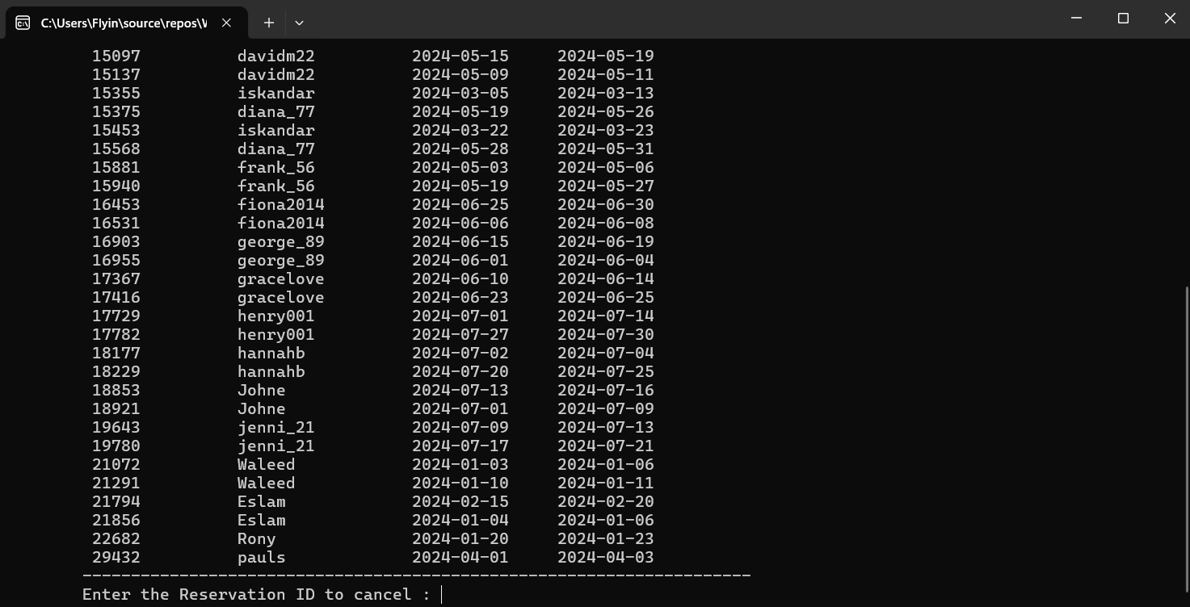

- Third service is receipt generation Allow staff to print receipt from chosen Booking ID.
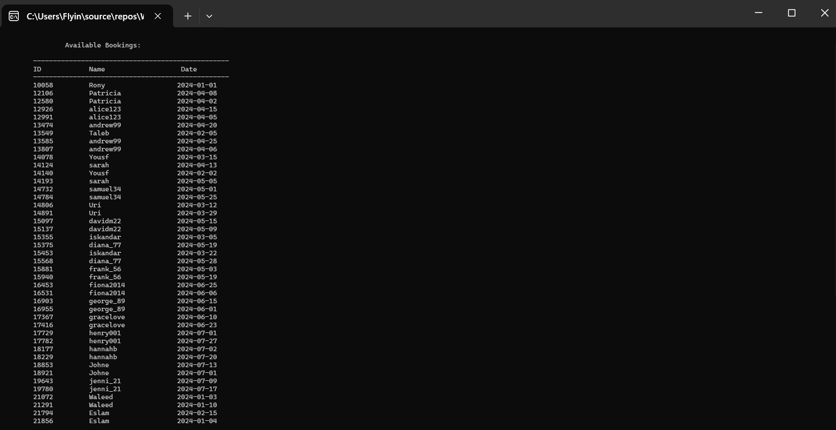

- Fourth Service is Voucher application and here the staff can make some discounts for eligible bookings.
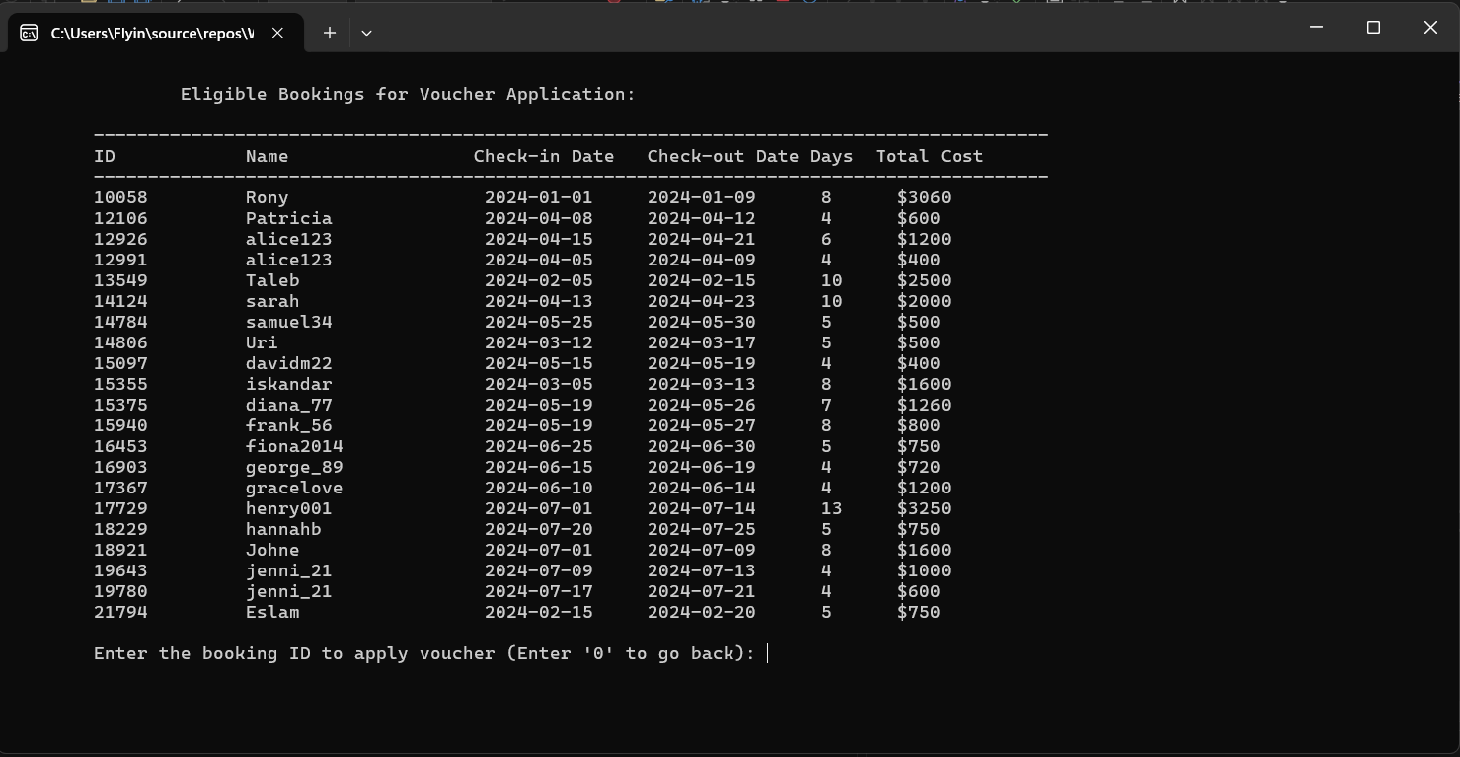

- As for the Guest main menu interface it contains 4 services also.
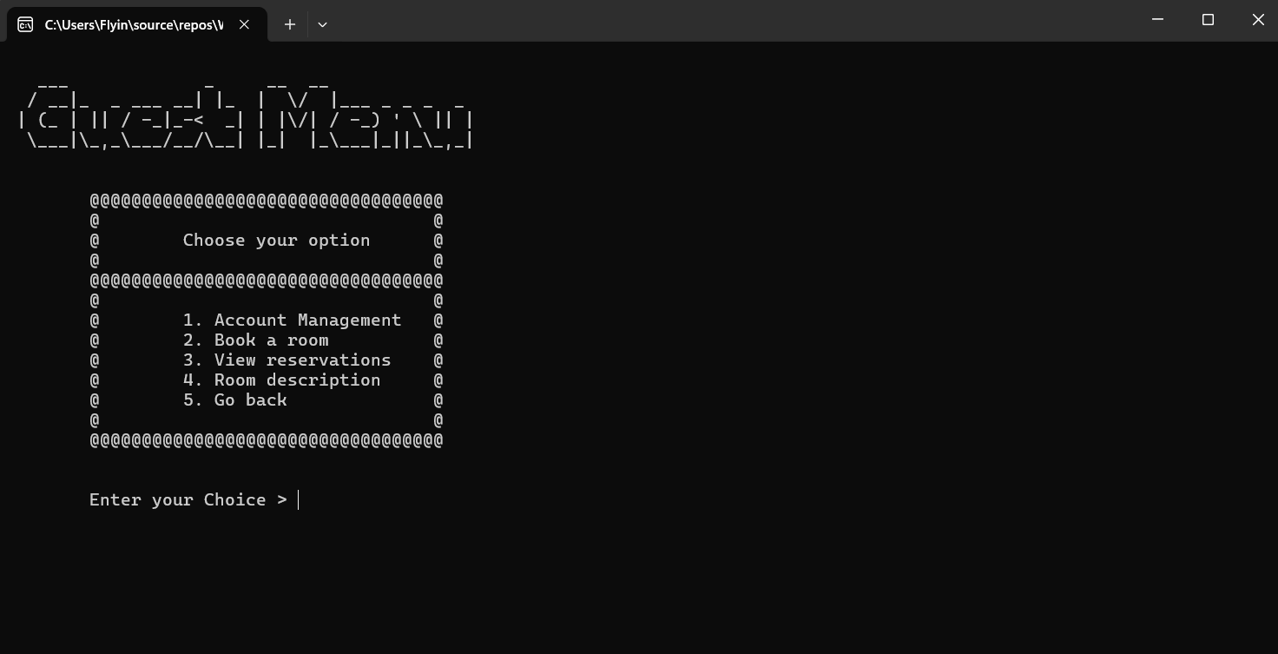

- First service is Account management where you can update or view credentials.
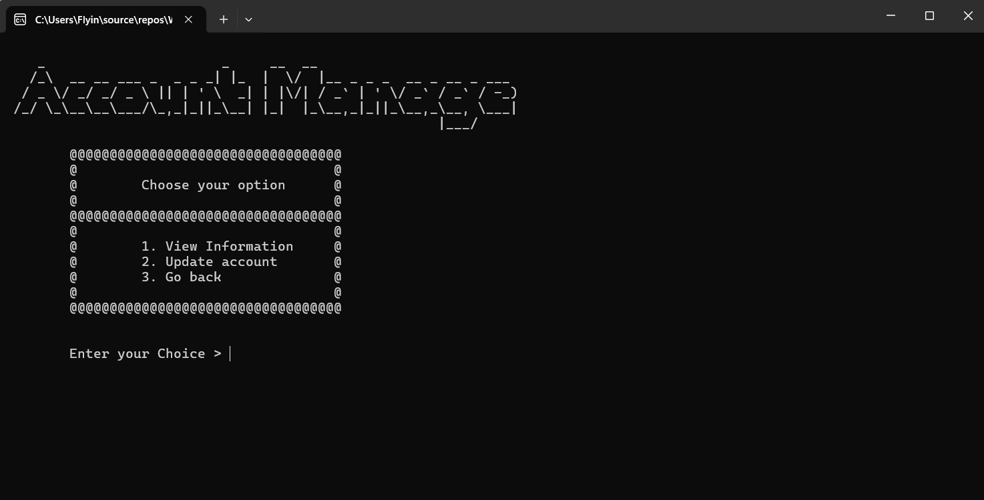

- Second service is Booking section where you can make reservations.
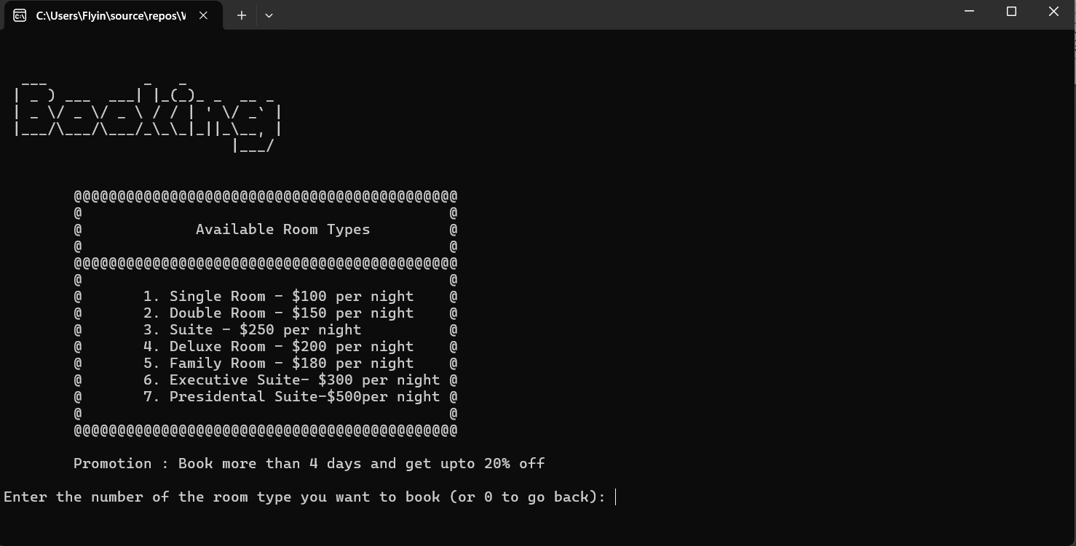

- Third Service is View reservation for Logged in account.
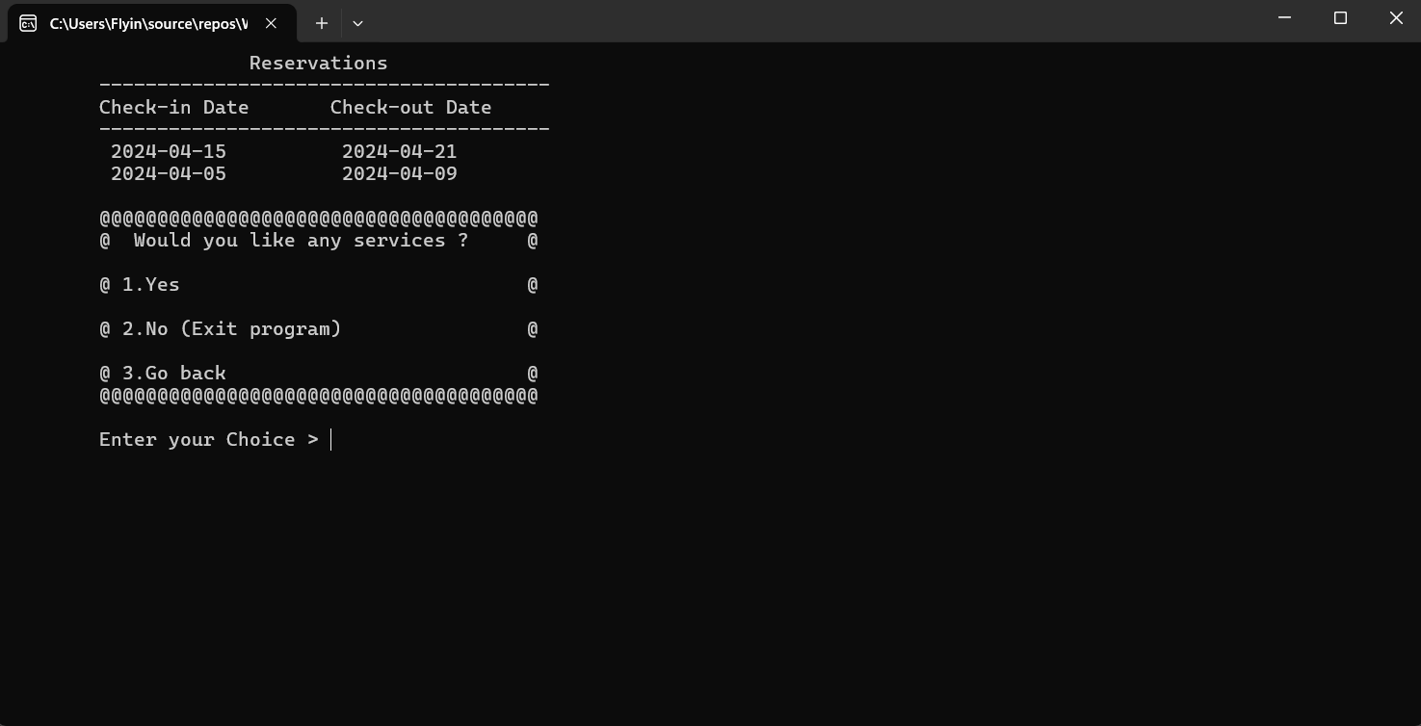
- Fourth Service is Room description Where the guest can get an overview of the room types.
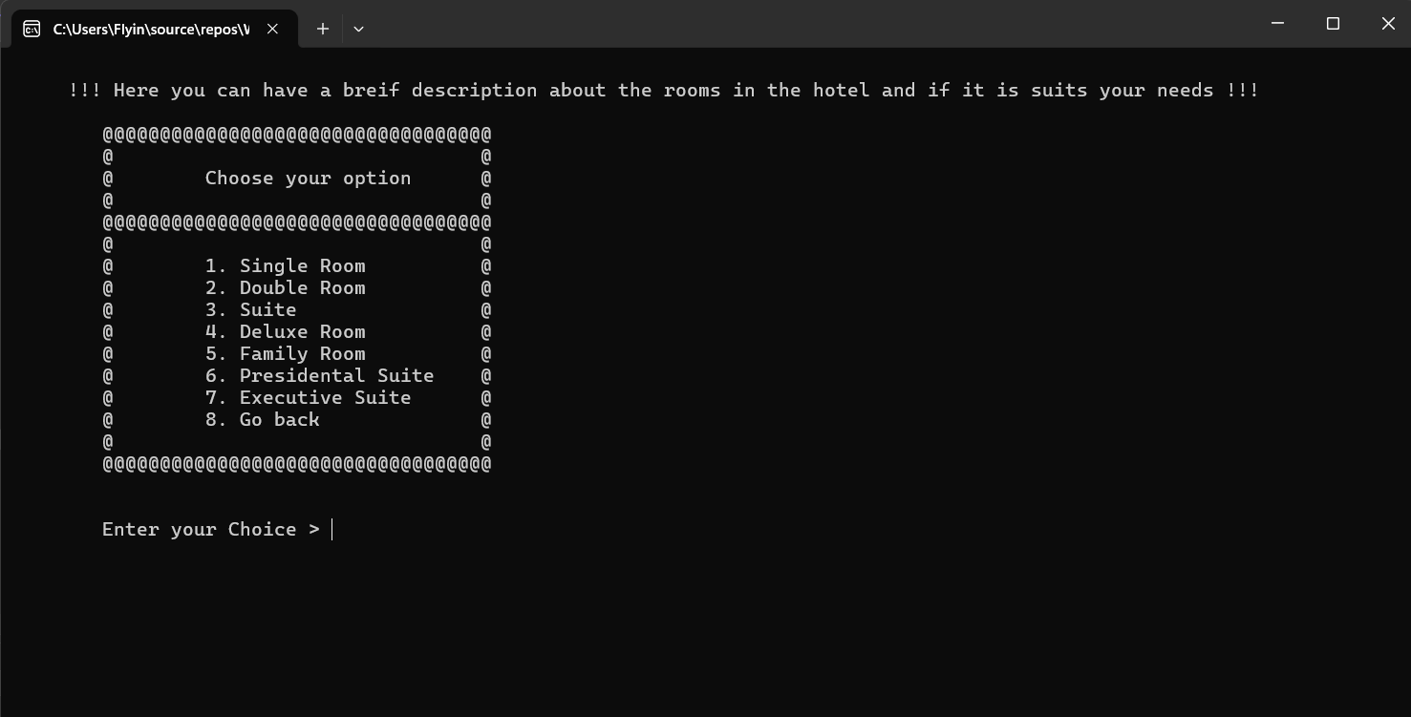

IMPLEMENTATION

Naming Convention
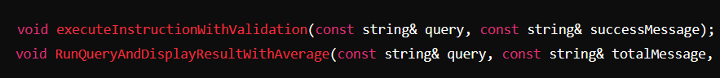
Both of these functions follow the camelCase convention and have clear, descriptive names.
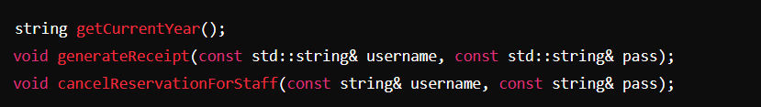
These names clearly describe their purpose: getting the current year, generating a receipt, and canceling a reservation for staff.
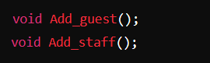
Even though these names are short, they are still descriptive and avoid unnecessary abbreviations.

USES OF CAMEL CASE:
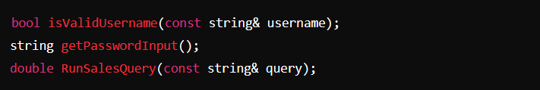
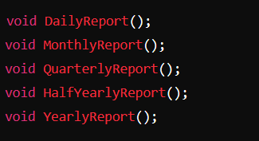
These functions are consistently named using Pascal Case for reports of different periods.
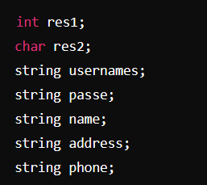
The variables are named descriptively based on their purpose (usernames for storing usernames).
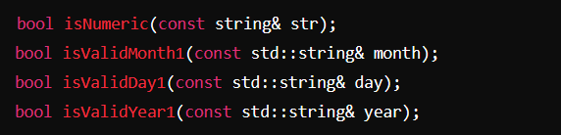
Boolean functions are prefixed with "is" to indicate they return a Boolean value.
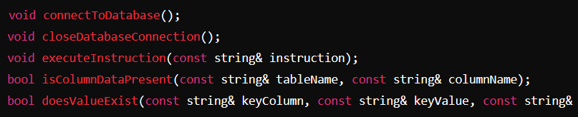
These functions are named to clearly describe their database-related operations.

Function
Function Declaration (Prototype): This specifies the function's name, return type, and parameters (if any), providing the compiler with information about the function.
For example: 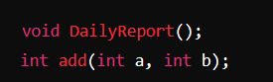

Function Definition: This is the implementation of the function, where the actual code resides. It includes the same signature as the declaration.
For example:
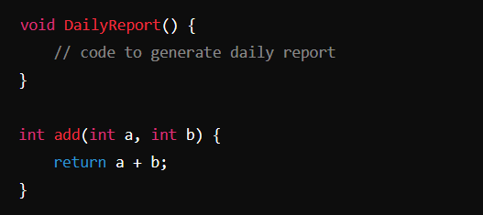

Return Type: Indicates the type of value the function returns. If a function does not return a value, it uses the void keyword.
For example:
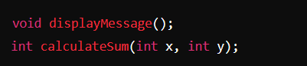
Parameters: Variables that are passed to the function. They allow functions to operate on different values.
For example :
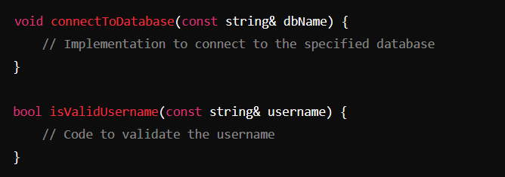
Function Call: This is where the function is invoked to execute the block of code it contains.
For example:
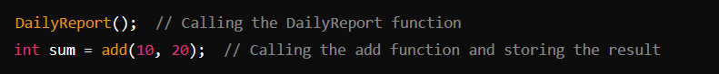
Scope and Lifetime: Functions can have local variables that exist only within the function's scope. Once the function completes execution, these variables are destroyed.
For example:
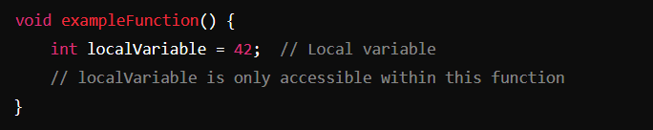

Array
Declaration and initialization: Specifies the type of elements and the number of elements in the array.
For example:
Accessing Elements: Elements in an array are accessed using indices, starting from 0.
For example:
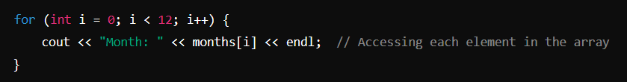
Usage in Functions:
Arrays can be passed to functions to perform operations on them.
For example:
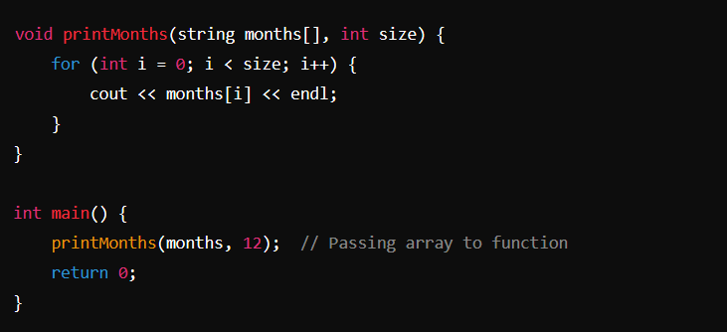
Multidimensional Arrays:
While no direct example of a multidimensional array, here's an illustrative example:
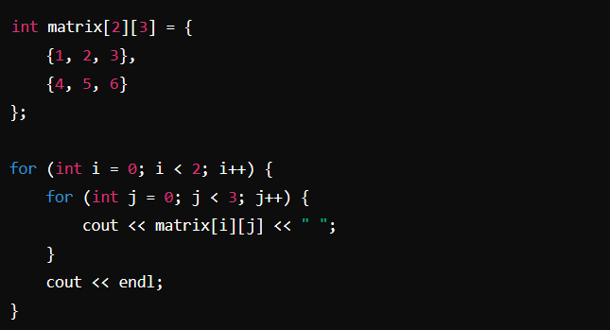

Selection
if Statement:
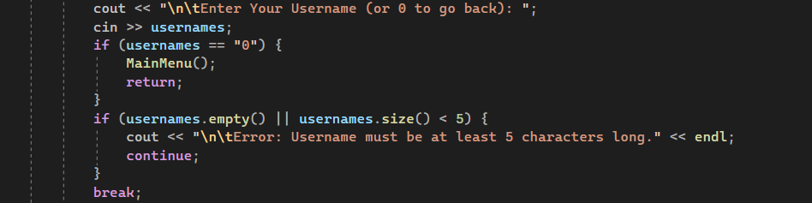
If-Eles if-else statement:
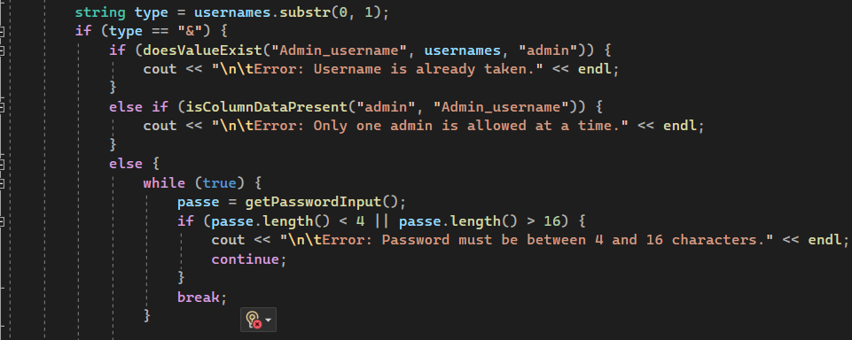
If statement:
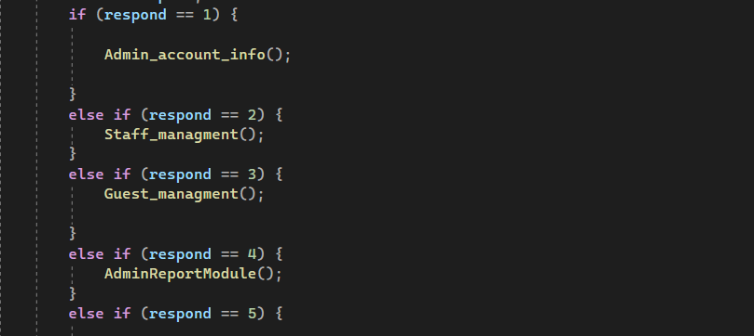
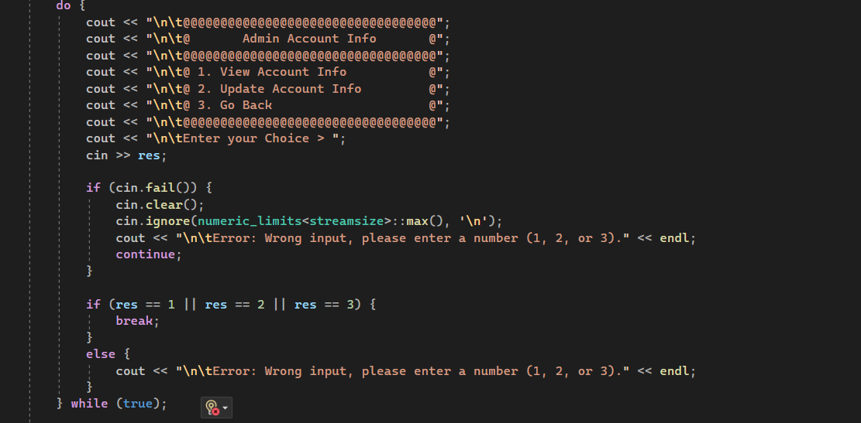
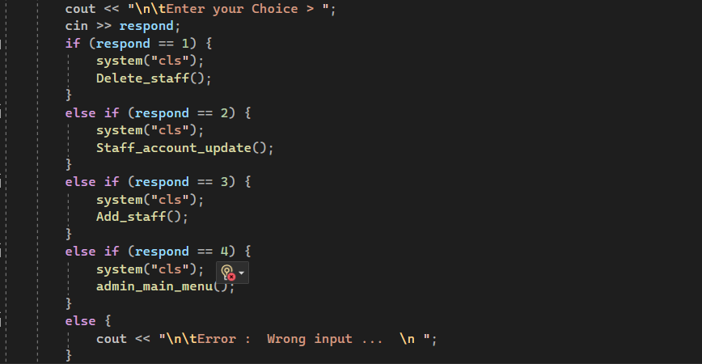

Control
Sequential Control:
Sequential control is the most straightforward form of control flow, where statements are executed in the order they appear.
For example:
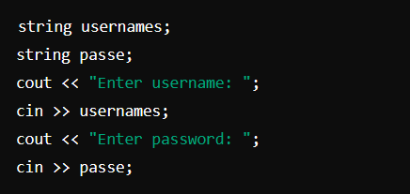
Selection Control:
if Statement:
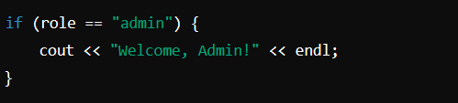
Repetition Control
for Loop:
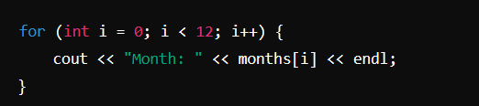

while Loop:
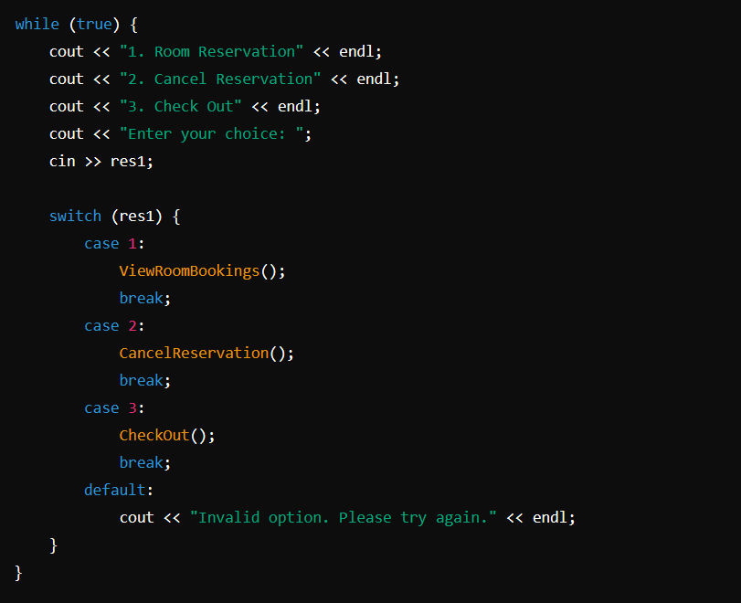
Jump Control
break Statement:
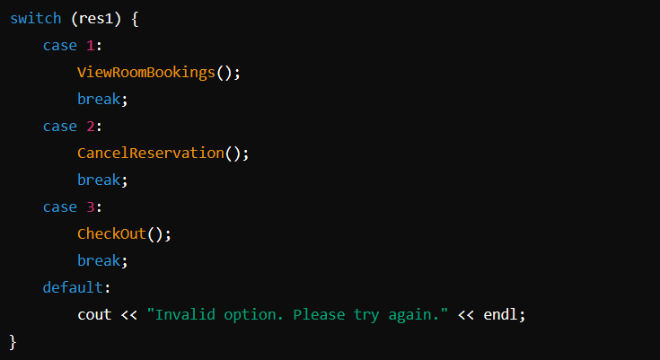
return Statement:
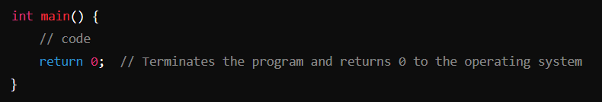

Pointer
Declaration and Initialization:
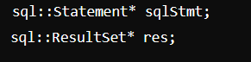
Initialization:
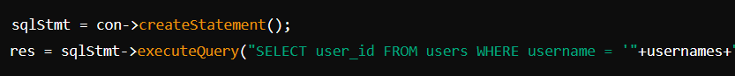
Dereferencing:
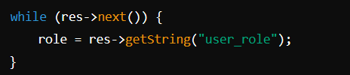
Pointer Arithmetic illustrative example-based context:
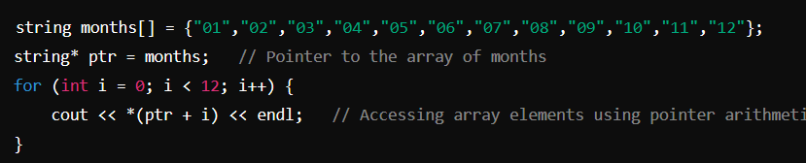
Dynamic Memory Allocation:
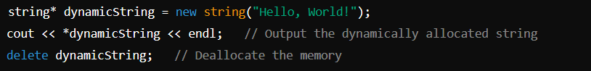

Error Handling
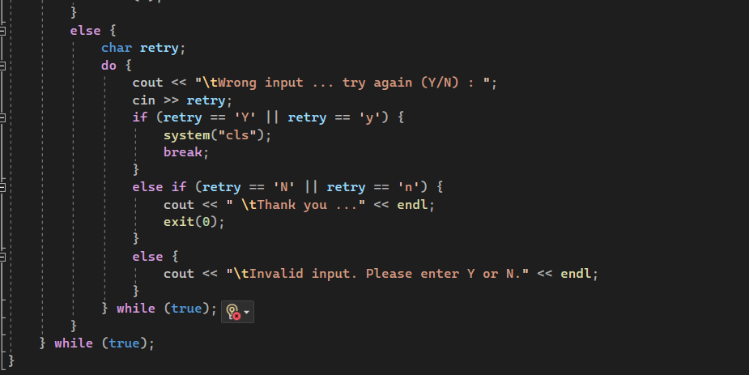
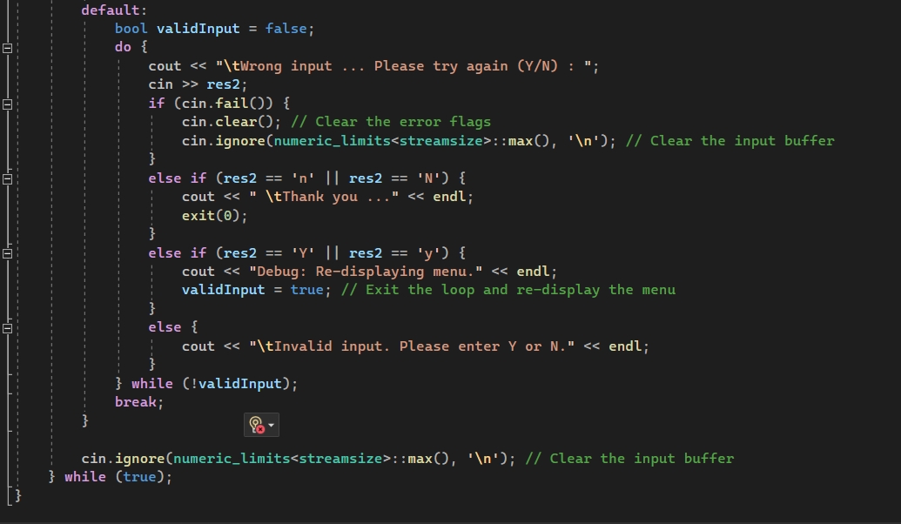
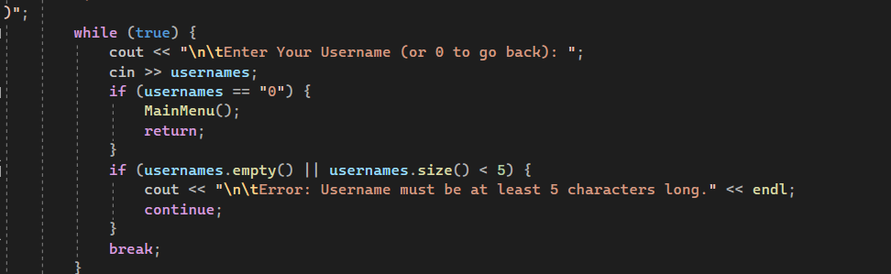
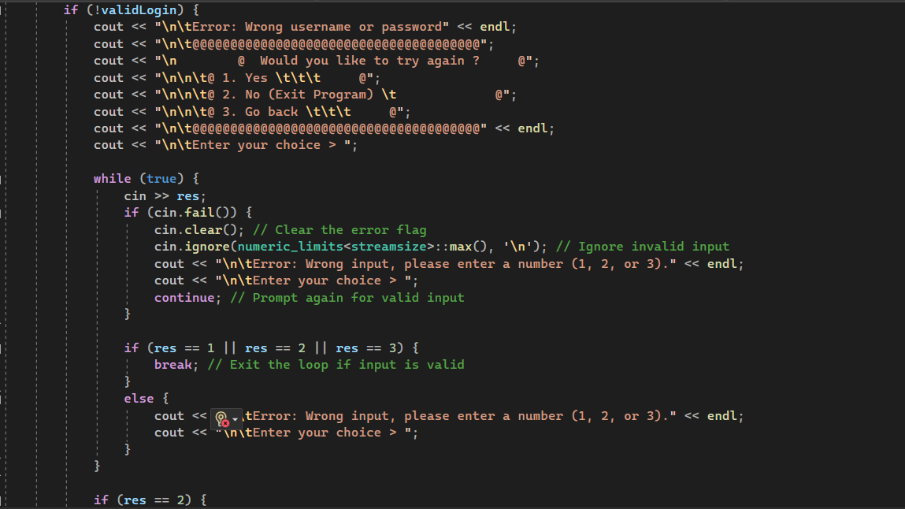
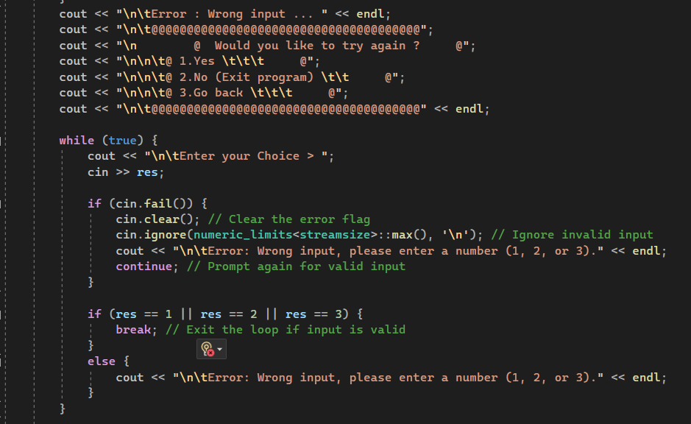
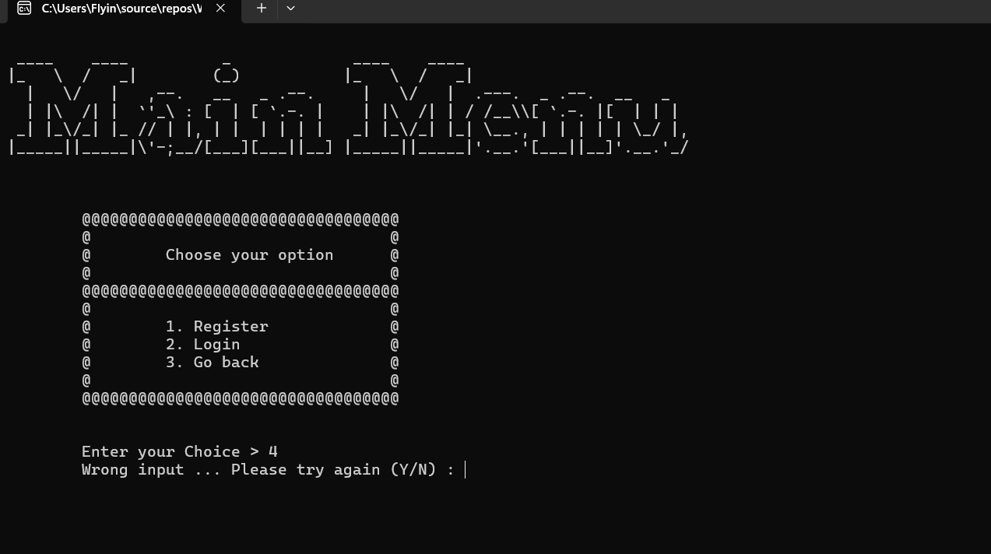
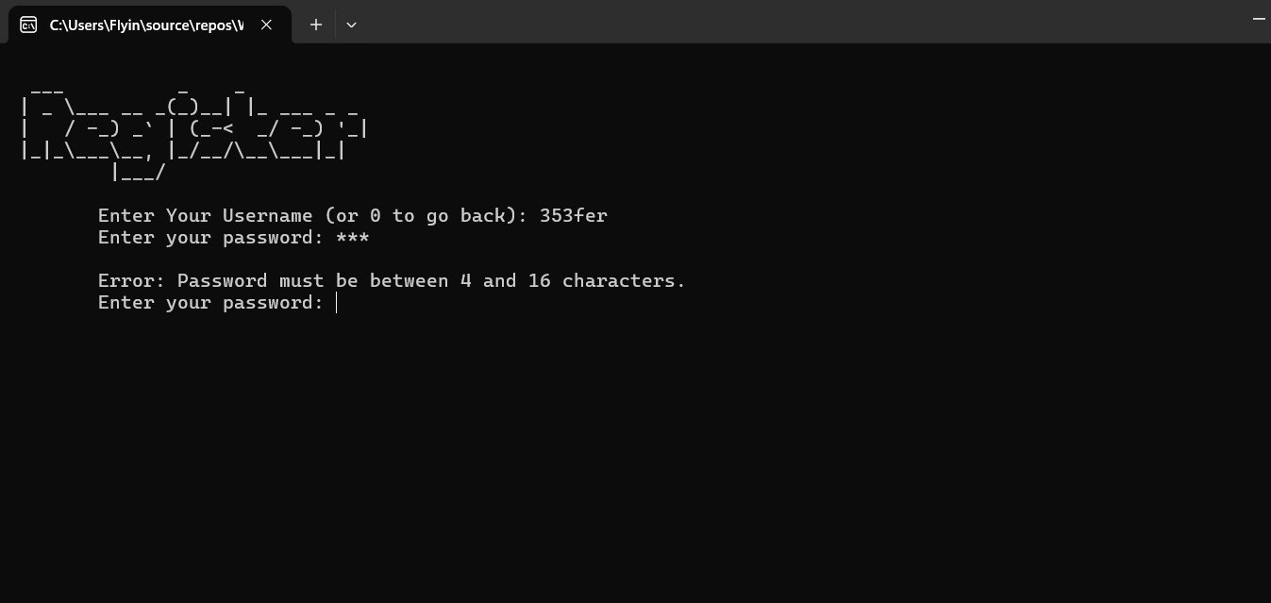
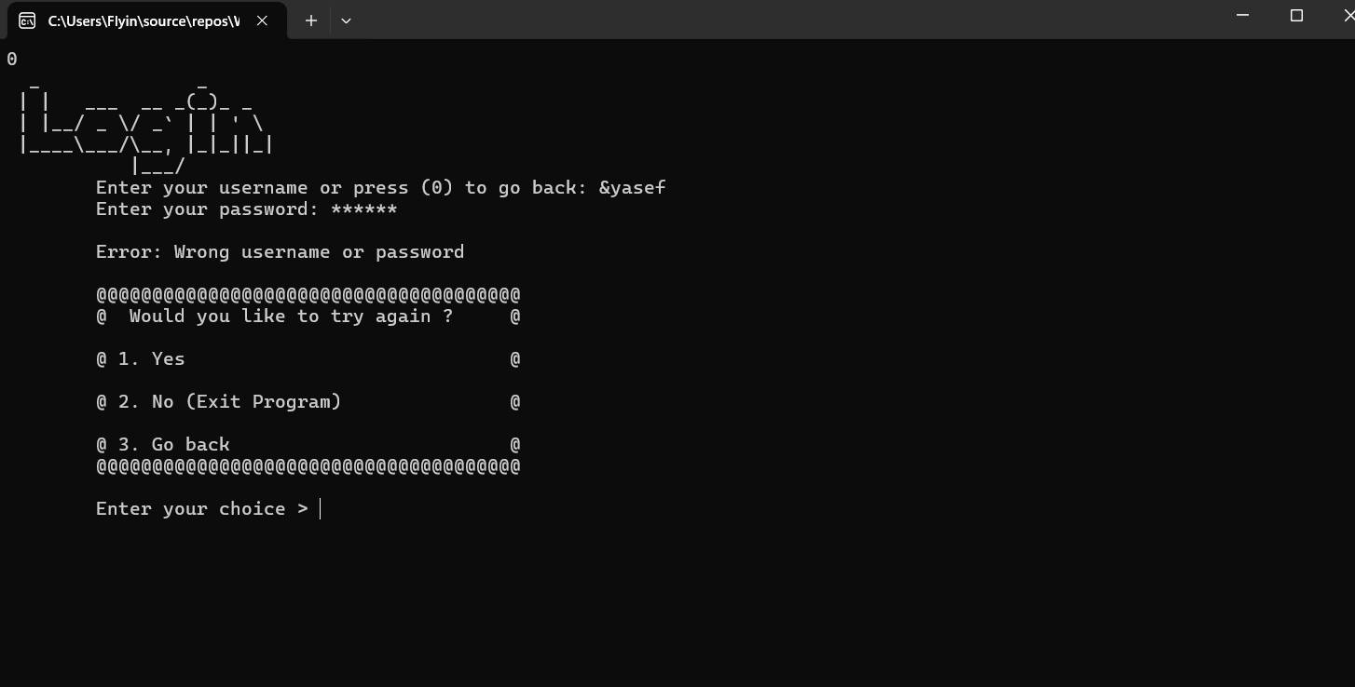
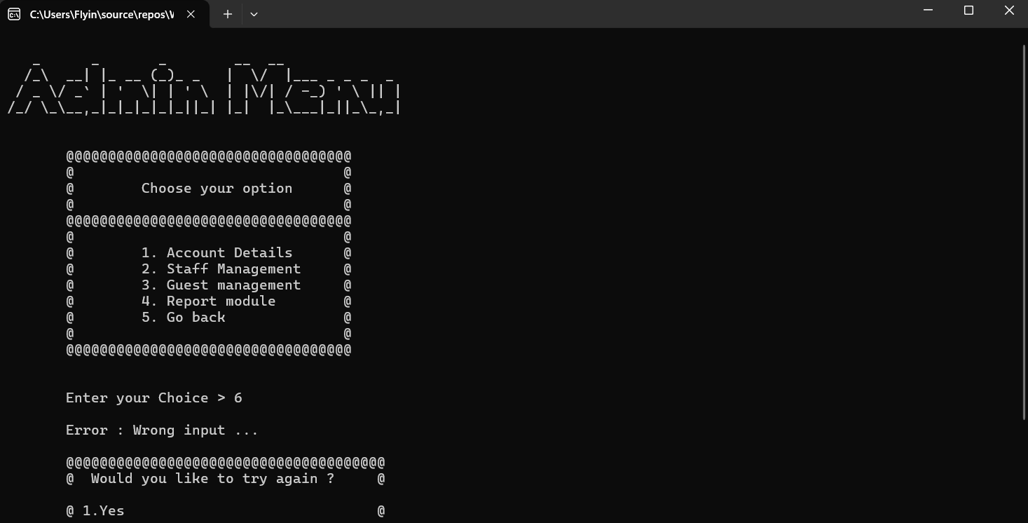
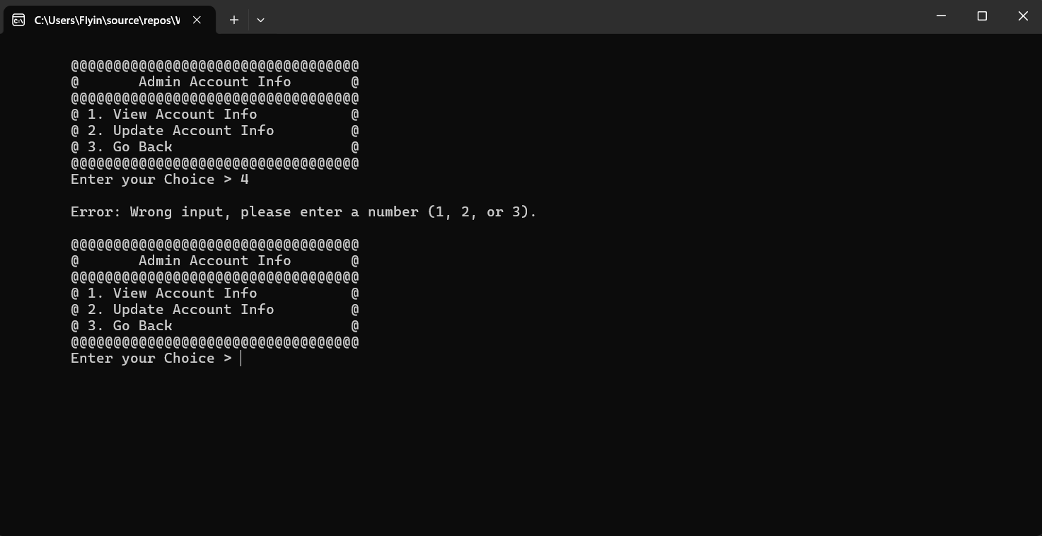
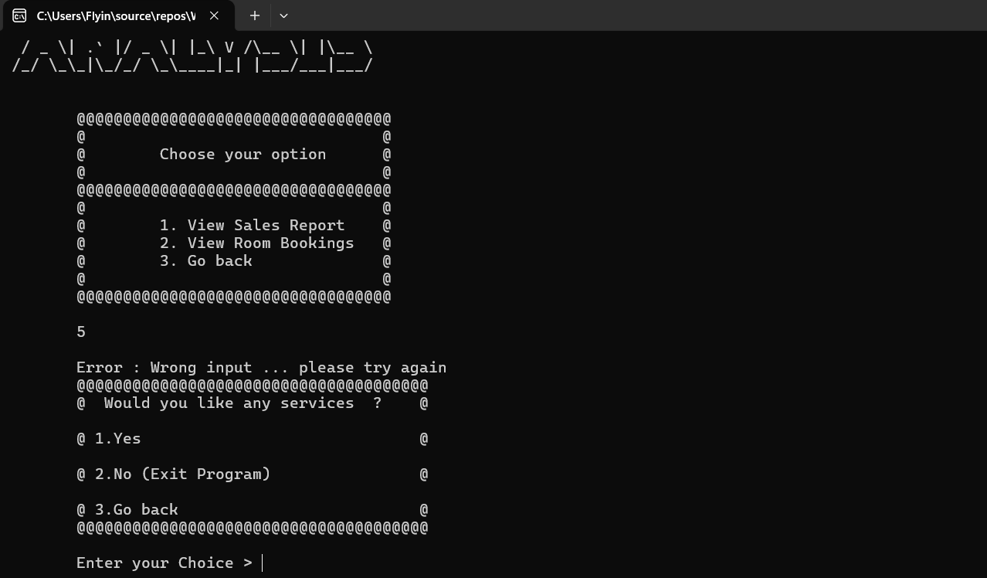
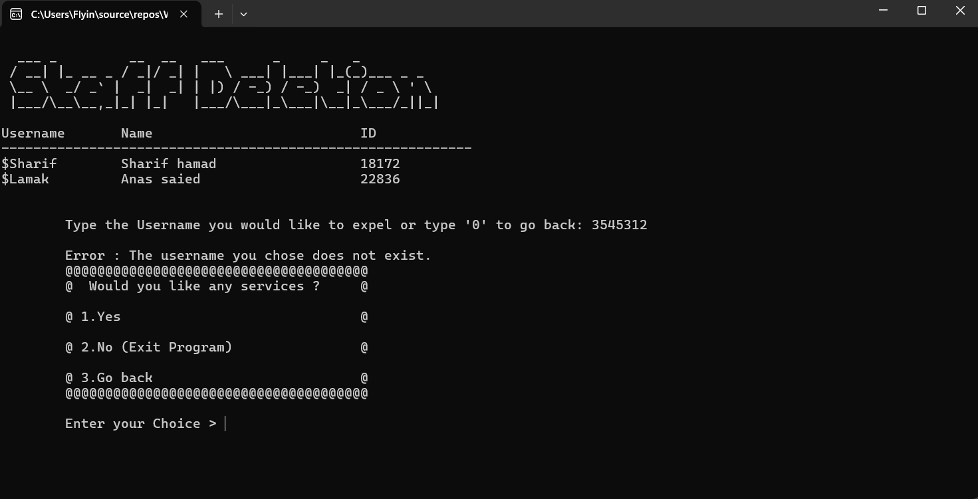
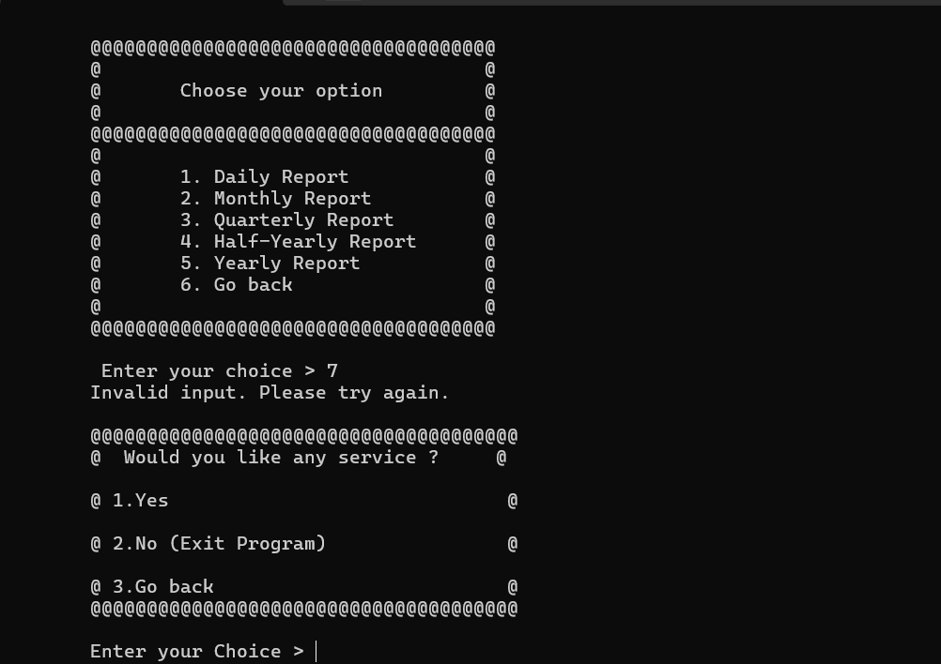
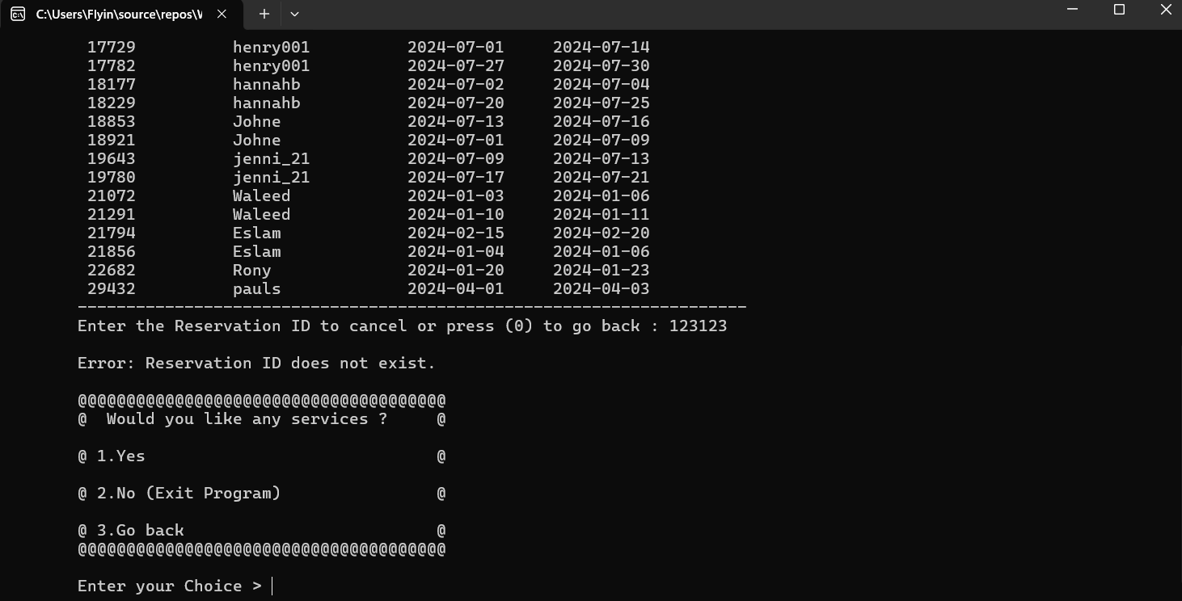
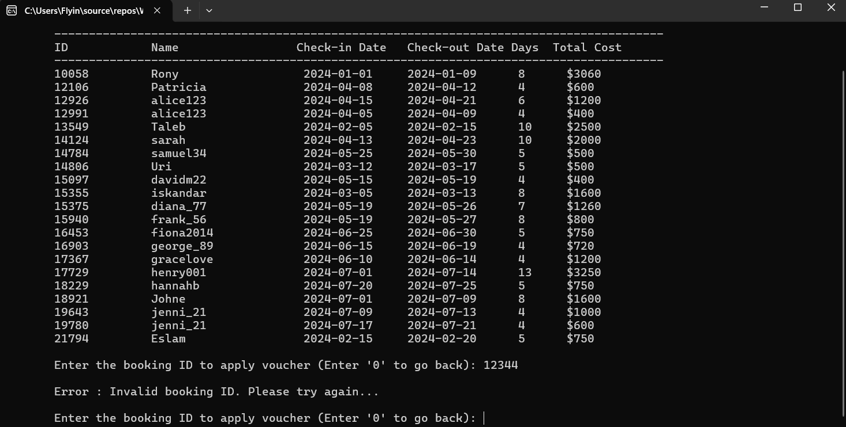
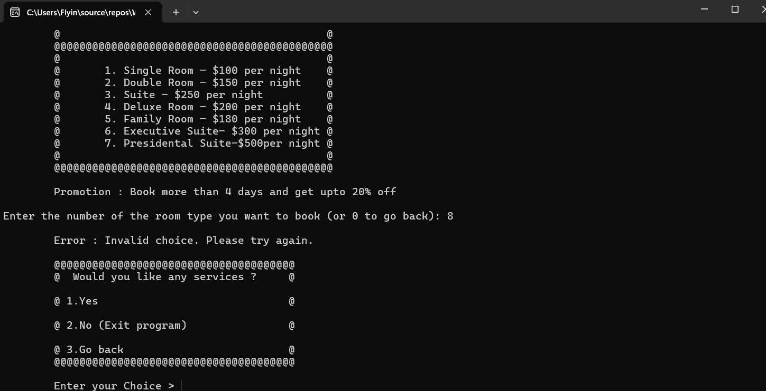

CONCLUSION

Constraints
These constraints can impact the project's scope, timeline, resources, and overall feasibility. Here are some potential constraints for a hotel management system.
- Budget Constraints:
The project must be developed within a specific budget, which limits the resources available for development, testing, and deployment. This can affect the choice of technology, the size of the development team, and the scope of the features implemented.
- Technical Constraints:
The system must be compatible with existing hardware and software infrastructure within the hotel. This includes ensuring the system works with current databases, servers, and any other integrated systems such as payment gateways or room management tools.
- Regulatory Constraints:
The system must comply with relevant regulations and standards, such as data protection laws (e.g., GDPR), industry standards for security, and specific hospitality industry regulations. This may require implementing specific security measures, user consent mechanisms, and data handling procedures.
- User Requirements:
The system must meet the needs of various user groups, including hotel staff, management, and customers. This includes ensuring the system is user-friendly, accessible, and capable of handling multiple user roles and permissions.
- Integration Constraints:

The system must integrate seamlessly with existing systems and processes within the hotel. This includes integration with booking systems, payment processing, room management, and any third-party services used by the hotel.

Future Improvements
To address the constraints and limitations identified in the Hotel Management System (HMS), several future improvements can be proposed:
- Enhancement of User Interface (UI) and User Experience (UX):
Current Constraint: The existing command-line interface may not be user-friendly for all users, especially those not familiar with command-line operations.
Future Improvement: Develop a graphical user interface (GUI) that is more intuitive and easier to navigate. This can be achieved using modern UI frameworks such as Qt for C++ or moving to web-based solutions using frameworks like React or Angular with backend integration.

- Advanced Features and Integrations:
Current Constraint: The system currently supports basic hotel management functions.
Future Improvement: Add advanced features such as integration with third-party booking platforms (e.g., Booking.com, Expedia), real-time analytics and reporting, and automated marketing tools. This will enhance the system's capabilities and provide more value to users.
- Security Enhancements:
Current Constraint: Security measures need to be continually updated to protect against new threats.
Future Improvement: Implement advanced security features such as two-factor authentication, encryption of sensitive data, and regular security audits to ensure the system is protected against vulnerabilities.

- Mobile Application Development:

Current Constraint: The system is currently accessible only through desktops.
Future Improvement: Develop mobile applications for iOS and Android platforms, allowing staff and guests to manage bookings, check-ins, and other operations directly from their mobile devices.

REFERENCES

"The C++ Programming Language" by Bjarne Stroustrup: Written by the creator of C++, this book is a comprehensive resource covering both basic and advanced concepts.

"Effective C++" by Scott Meyers: This book provides 55 specific ways to improve your programs and designs.

"C++ Primer" by Stanley B. Lippman, Josée Lajoie, and Barbara E. Moo: This is an excellent book for beginners and provides a solid foundation in C++.

"SQL in 10 Minutes, Sams Teach Yourself" by Ben Forta: A quick guide to understanding and using SQL.

"Learning SQL" by Alan Beaulieu: A more in-depth book for learning SQL from scratch.

"SQL Cookbook" by Anthony Molinaro: Provides practical solutions to common problems faced when working with SQL.

"Introduction to Algorithms" by Thomas H. Cormen, Charles E. Leiserson, Ronald L. Rivest, and Clifford Stein: Often referred to as CLRS, this book is a comprehensive guide to algorithms and data structures.

"Data Structures and Algorithm Analysis in C++" by Mark Allen Weiss: A good book focusing on data structures and their implementation in C++.

"Algorithms in C++" by Robert Sedgewick: This book covers a wide range of algorithms and their implementations in C++.

